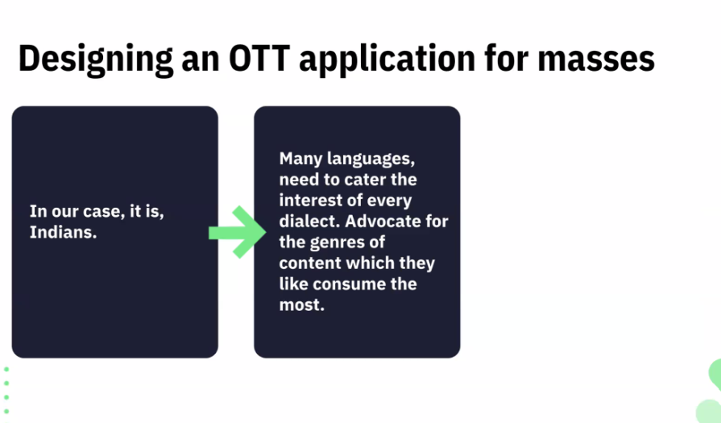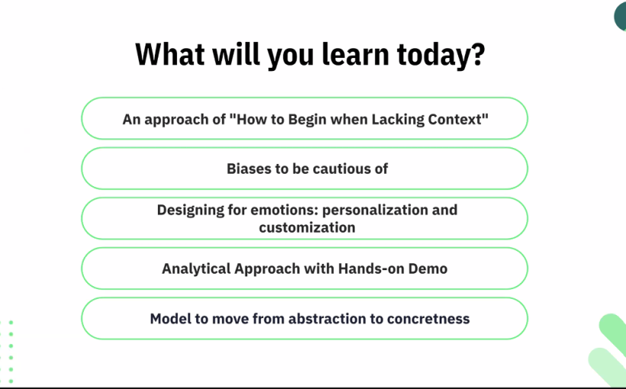

Consider having a essential features which are of interest.

1. Analyuse multiple groups to ensure preference which helps in customization ogf the product.
2. Categories in gender , language,country and age – in order to code the algorithm to the need or requirement.

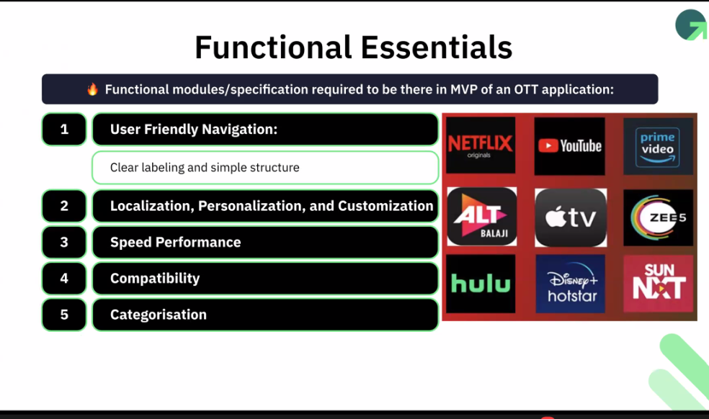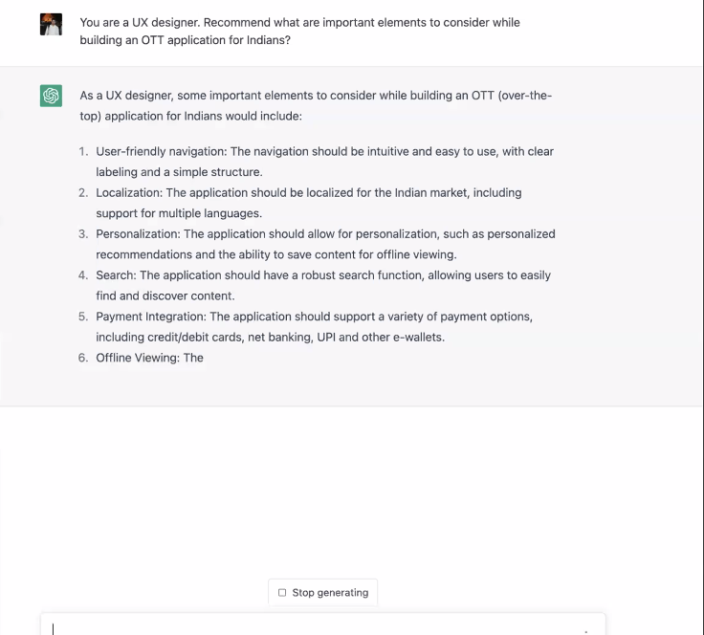

6. documentations

7 faqs

Create a flow chart

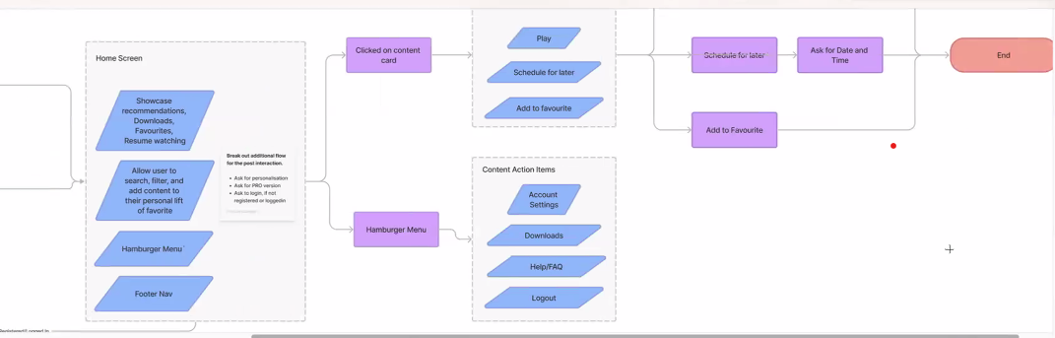

Using Midjourney – prompting to generate visuals for the platform.

Midjourney – ai image generation tools

Creating a skeleton of the apps main ui system or first.

Make a design to eleict a emotion from a user.

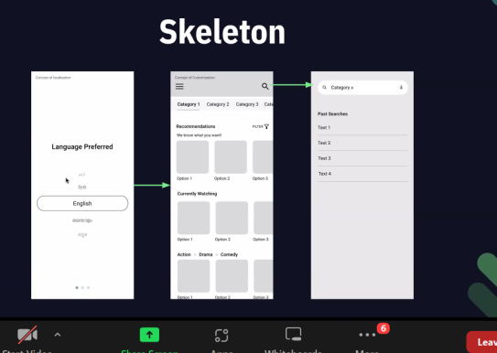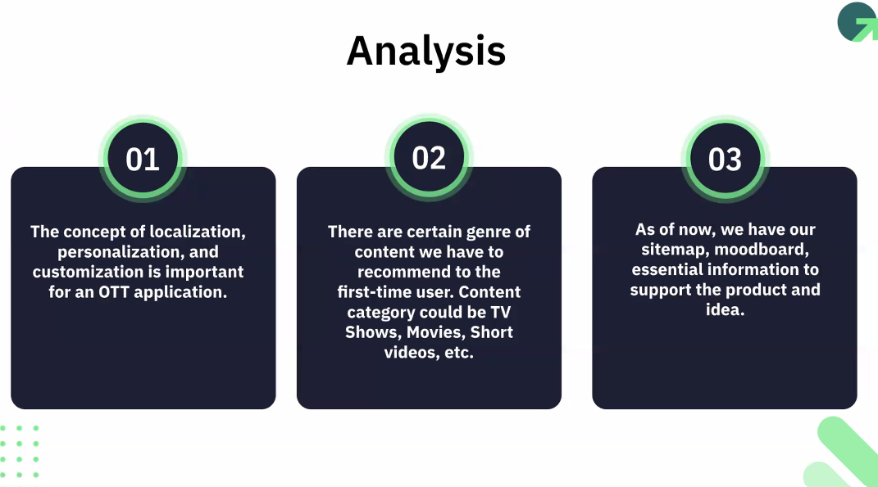

Understanding the audience – use maze an application. For user feedback. It free.

Create a journey for the audience to take upon.

Analyse data for insight.

Aligning data for business need.

Why certain patterns are shown in certain solutions

Shorlist the data - don’t selectively source data – selectivity bias

Certain patterns are still to be unearthed.

